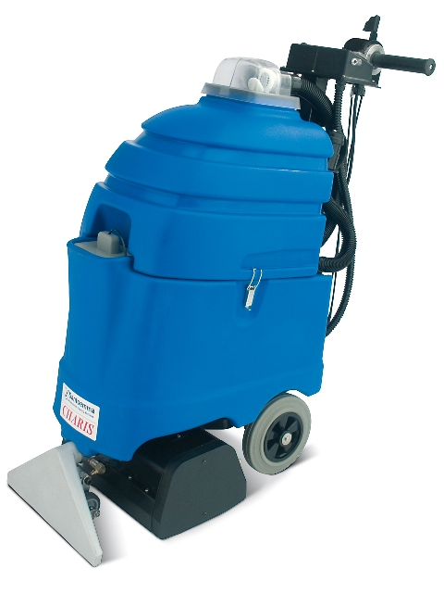
Charis-DUAL is a patented self-contained machine for cleaning middle areas of carpet, with several innovative features.

Charis-DUAL has a 16” wide cleaning path. Thanks to its 2 counter-rotating brushes, the dirt is removed from the base of carpet fibres. It is also possible to adjust the brush pressure, according to the type of carpet. The water-flow can be adjusted, for a maintenance low-moisture cleaning or a restoration deep-cleaning.

Santoemma high waterlift vacuum system allows an excellent removal of the dirt and a shortest drying time: carpet can be dry in one hour!
With only 60 decibels, it is possible to work without disturbing other people.

The patented “click” system allows to manoeuvre the machine in a lightest way. It is possible to work for many hours without effort.
With Charis-DUAL it is also possible to perform a deep pre-brushing of carpet before extraction cleaning, which is useful for very dirty carpet areas.

Adding the patented SMARTKIT system, it is possible to perform automatic chemical dosing, carpet pre-spraying and rinsing.

The optional squeegee SQ720E allows to clean hard floor, moving forward. Charis-DUAL is transformed in a powerful scrubber drier, with 2 cylindrical brushes. Extra brushes, specific for hard floor cleaning, are also available.

Main application fields: cleaning companies, hotels, conference halls, restaurants, clubs, pubs, offices, banks, shops, cinemas, theatres, ferry boats, ships, airports, fitness centres, school, universities, shopping centres, places of worship and all places with middle-sized surfaces of carpet.

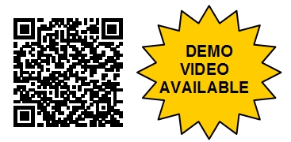
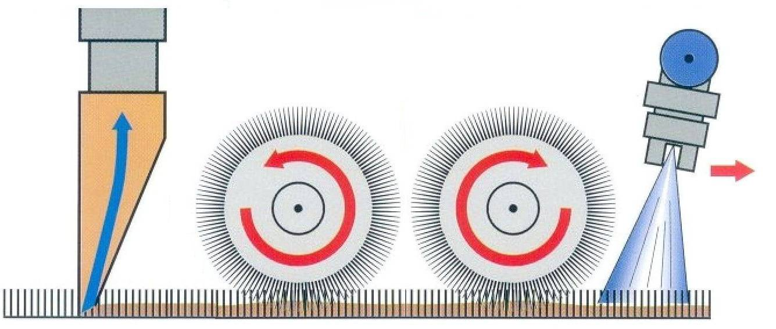

Injection-extraction cleaning with counter-rotating brushes

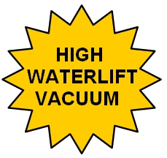
Waterlift
Drying time
Residual dirt

Santoemma
Charis-DUAL

Standard
carpet extractors

Charis-DUAL patented “CLICK” System
After cleaning a stripe of carpet, moving backwards, it is enough to slightly push the handle down and special support wheels will raise the machine, which can easily slide forward to the beginning of next stripe, without any effort for the operator. It is not necessary to bend the machine back towards the operator and push it forward, keeping it in equilibrium on the rear wheels, as happens with all pull-back extractors on the market.
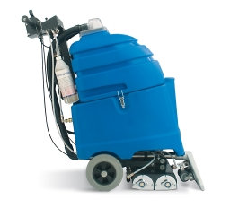
CLEANING

MOVING FORWARD

Carpet pre-brushing and cleaning with the same machine
With Charis-DUAL it is also possible to perform a deep pre-brushing of carpet before extraction cleaning, for a deep mechanical brushing action. Normally this operation requires a dedicated machine, such as a single disk. With Charis-DUAL everything can be done with just one machine.
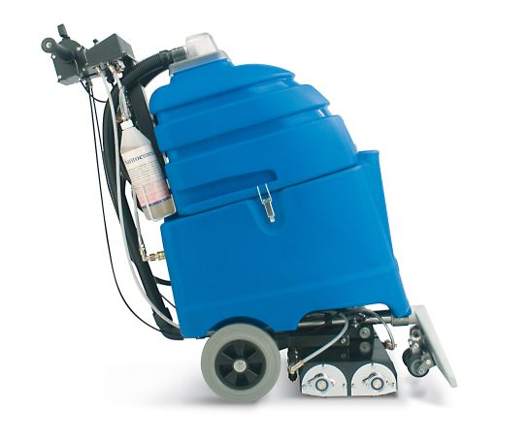
PRE-BRUSHING

CLEANING

Optional SMARTKIT system
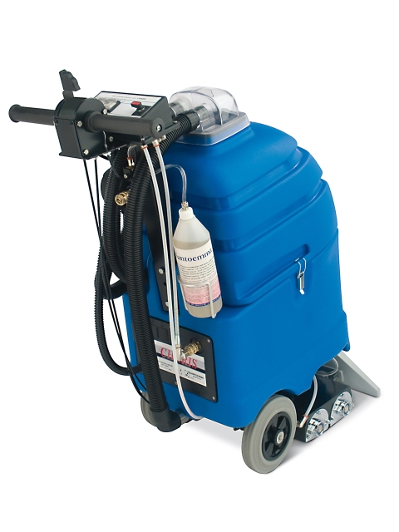
Adding to Charis-DUAL the patented SMARTKIT system, it is possible to perform carpet pre-spraying with concentrated chemical solution, automatic chemical dosing and carpet rinsing. The chemical is put as concentrated in a bottle and the machine’s tank contains clean water only. When chemical injection is required, the machine automatically sprays chemical in an optimal concentration, either during carpet extraction cleaning or in carpet pre-spraying.

During extraction cleaning with chemical, a controlled chemical concentration is ensured, with no need for the operator to perform any dilution. Wrong chemical concentrations and waste of chemical are avoided.
Using a dedicated pre-spray hose and gun, it is possible to pre-spray carpet with a concentrated chemical solution. Pre-spraying carpet with a concentrated chemical solution allows a longer dwell time for the chemical, which helps detaching the dirt from carpet fibres.

With SMARTKIT, it is possible to let the machine work with clean water only, in order to rinse carpet fibres, removing any sticky chemical residual and ensuring a slow resoling after cleaning.

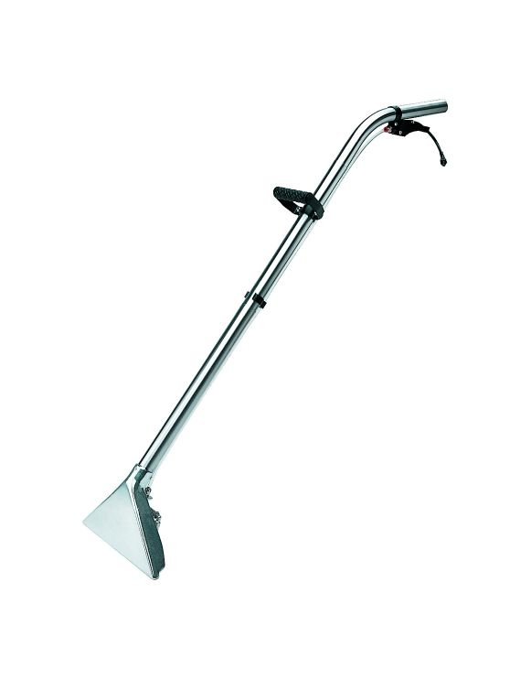
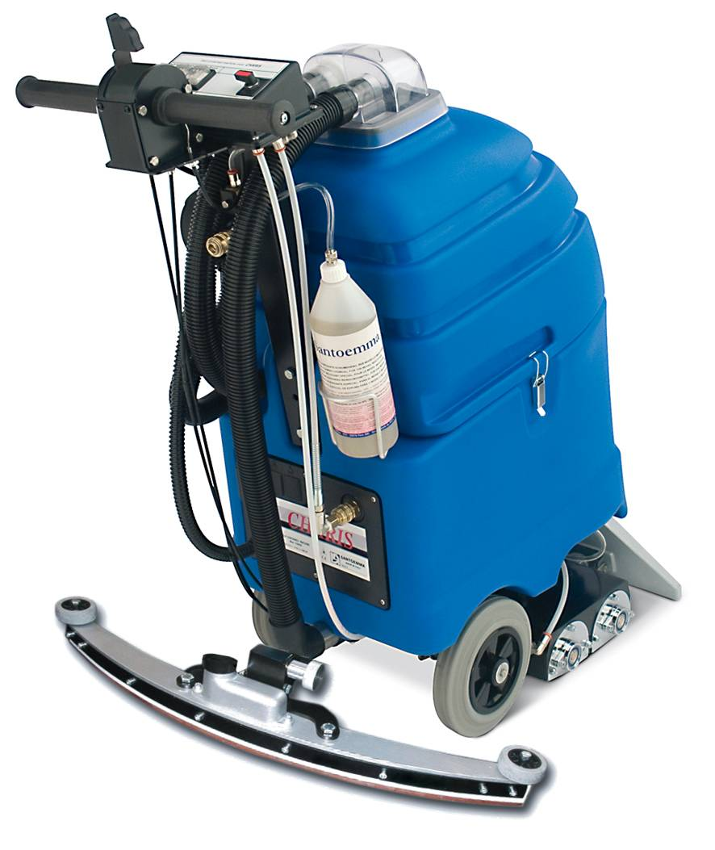

HARD FLOOR CLEANING

Optional wand NS300 Optional Squeegee for hard floor

Advantages of Charis-DUAL:
- Great cleaning power, thanks to the 2 counter-rotating brushes, which allow to clean the carpet fibres deeply and from all sides. No residual dirt will re-emerge on carpet surface after few days!
- The 3 stages high waterlift vacuum motor and the special profile of the vacuum head allows an excellent suction and therefore a complete dirt removal and a very short drying time.
- Very silent working (60 decibels), allowing to use the machine with no discomfort for the worker and for other people. The machine can be used also during normal daily working time and in noise-sensitive places such as hotels, offices, banks.
- The patented “click” system allows to work with the machine for many hours without any effort for the operator.
- Possibility to adjust the height of the brushes according to the kind of carpet and to the dirt degree.
- Possibility to pre-brush carpet, useful for particularly dirty areas.
- Brush easily replaceable with no need of turning the machine over.
- Controls at a comfortable height for the worker.
- Water spraying can be continuous or otherwise activated by the machine handle.
- Quick disconnect spray nozzles, which can be removed without using any tool. The nozzles can be cleaned easily. The complete connector with nozzles can be taken out of the machine without turning the machine over.
- Possibility to connect the machine with optional tools for cleaning hard-to-reach corners.
- Possibility to regulate the water flow, according to the degree of dirt and to the desired drying time.
- With the optional SMARTKIT-CH, it is possible to perform automatic chemical dosing and carpet rinsing.
- Adding the pre-spray pipe and gun PRESPRAY-MX to SMARTKIT-CH, it is also possible to pre-spray carpet before cleaning, in order to get the best cleaning results and avoid fast resoling of carpet.
- Possibility to clean both carpet and hard floor with a single machine, by using the optional squeegee SQ720E. The squeegee is connected to the machine thanks to a quick disconnect coupling which does not require to use any tool.
- Possibility to use an optional harder brush specific for hard floor.
Other technical advantages of Charis-DUAL:
- Detachable tanks. The machine can be carried easily even in a small car.
- High density polyethylene tanks, very strong and made for lasting a long time.
- Transparent unbreakable cover, which allows to see the dirty water while it is sucked.
- Easy to reach hole for filling the tank with clean water.
- Drainpipe for easily emptying the recovery tank.
- The gaskets are not glued and replaceable by hand. Easy to clean and change.
- Brass quick-disconnect couplings, reliable and strong.
- Water pump with internal bypass, which allows an automatic regulation of the optimal water flow according to the tool used.
Moreover, the bypass device makes the pump more reliable and avoids problems in the years.
- Water pump with external rectifier, specially sized for a greater reliability.
- Vacuum motor with thermal protection against overload.
- Vacuum motor treated against rust.
- Both motor and pump can work continuously.
- Stainless steel brush bearings for a longer life.
- Modular design that makes the maintenance easier. The maintenance of the machine can be done at low costs.
- Brush motor with thermal protection against overload and excessive mechanical action on carpet (useful in case of a wrong regulation of the brush height).
Technical Data
Approximate performance (basic machine)*: | 1600-3200 sqft/h
Approximate performance (professional SET)*: | 2500-3750 sqft/h
Recovery tank capacity: | 9 Gallons
Solution tank capacity: | 9 Gallons
Vacuum motor:  Power:  Maximum waterlift:  Maximum air-flow: | Three stages – High Waterlift  1500 W  134”  12 Gallons/sec.
Pump with by-pass:  Power:  Maximum pressure:  Maximum water-flow | Membrane  80 W  9 bar  1.2 Gallons/min
Cleaning width (carpet/floor): | 16”
Number of nozzles: | 5 + 1
Brush: | 2 x 120 W  600 rot/min  14.3”
Cable length: | 50 ft
Hose length: | (optional)
Weight (machine body): | 128 lbs
Weight (packaged machine): | 161 lbs
Dimensions: | cm 42 x 104 x 96(h)
Package dimensions: | cm 50 x 110 x 114 (h)
Standard colours: | Blue
Tank construction: | High density polyethylene
Suitable to work with heater: | YES
*The effective performance depends on the type of cleaning required: restorative deep cleaning - maintenance cleaning.

Complete machine for carpet cleaning | €

Suggested optional tools (see also Charis-DUAL PROFESSIONAL SET)
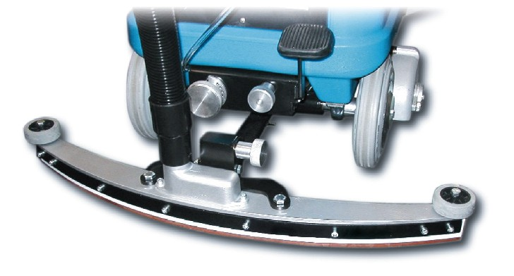 | SQ720E | 28” Squeegee for hard floor cleaning
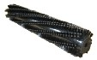 | 3692-30 | Brush specific for hard floor cleaning with Charis-DUAL.  2 brushes are needed for each machine.
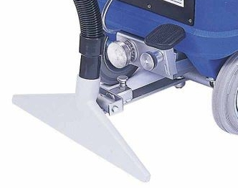 | 449C-ELITE | Rear vacuum head for carpet cleaning, allowing to clean carpet areas moving forward.
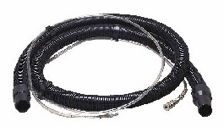 | H10-RAGNOL50-T | Vacuum and solution hoses, 16.5 ft Ragno solution pipe, metal couplings
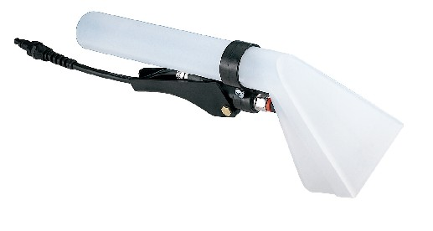 | NS10PN-M | Plastic hand tool, with 1 spray nozzle.
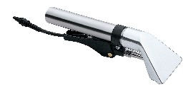 | NS10ALL-M | Aluminium hand tool, with 1 spray nozzle
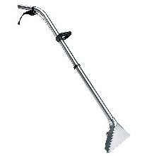 | NS300-M | Carpet tool with aluminium head, 3 spray nozzles, tubes in stainless steel
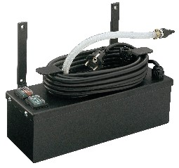 | HT1800-220-M | Instant hot water unit, 1800W, complete with metal brackets to fix it on the machine.
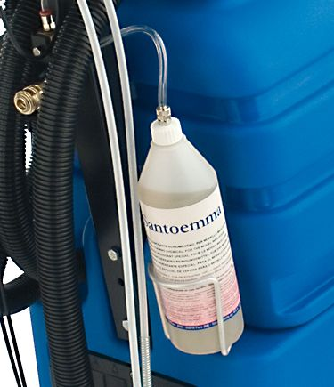 | SMARTKIT-CH | Kit for automatic chemical dosing, rinsing and pre-spraying. Not including the pre-spray pipe and gun (PRESPRAY-MX) for carpet pre-spraying.
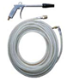 | PRESPRAY-MX | Complete pre-spray pipe and gun, to be added to SMARTKIT-MX or SMARTKIT-CH, for carpet pre-spraying.
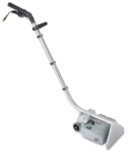 | NS270BRUSH | Special wand, 11” wide, with a cylindrical rotating brush, to be used for cleaning carpet in combination with an injection-extraction machine
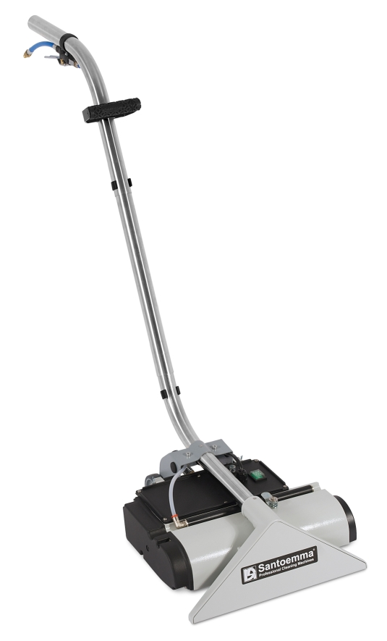 | NS400BRUSH | Special wand, 16” wide, with a cylindrical rotating brush, to be used for cleaning carpet in combination with an injection-extraction machine
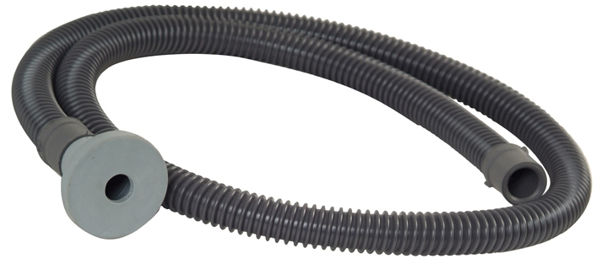 | 9022 | Hose for filling up the clean water tank easily. It can be used to connect the water tap to the machine tank, without spilling water.
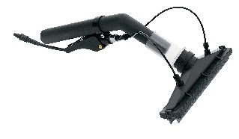 | HERMES-M | Tool which allows to wash and dry walls and windows. The solution is injected by 2 nozzles, which are inside the vacuum head, so that it is possible to clean a vertical surface without water dropping on the floor. Hermes is supplied with a brush slide and a rubber slide, to clean rough or smooth surfaces.
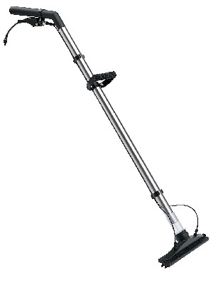 | NS270P-M | This tool works with the same principle of Hermes. Its two extensions allow to wash and dry hard floors, high walls and even ceilings.
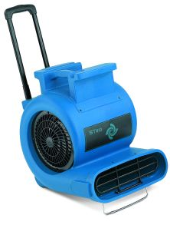 | ST810 | Three speed air blower, high performance, 1 Hp, 230V – 50Hz, for quick drying of carpet after cleaning. Equipped with wheels and extensible handle, easy to transport. Stackable.
Charis-DUAL PROFESSIONAL SET
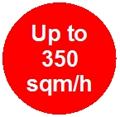

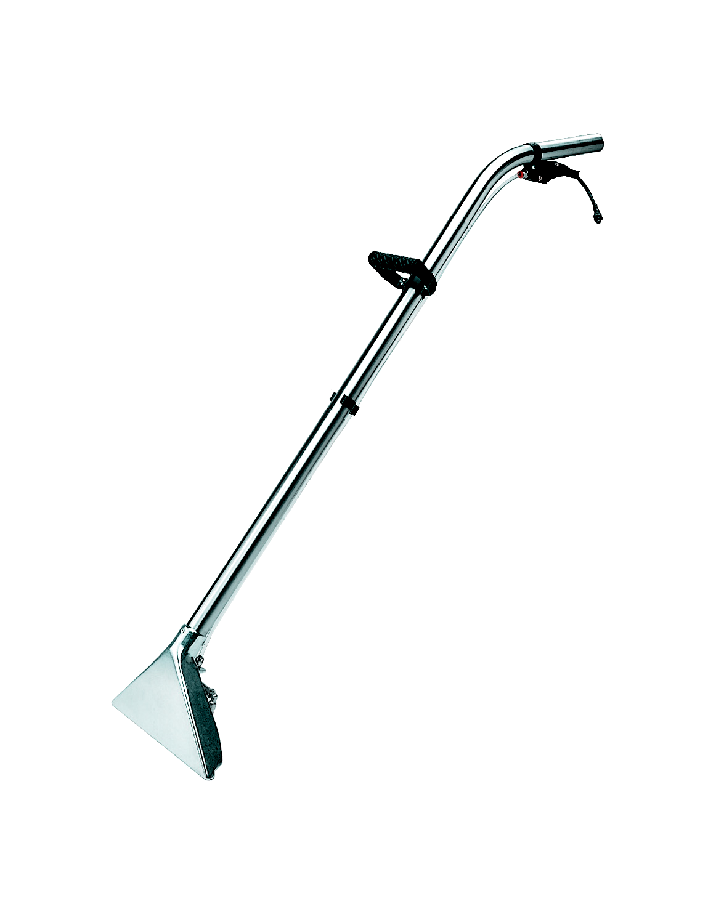
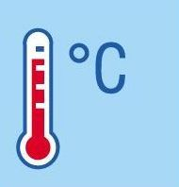
Hoses
H10-RAGNOL50-T

Wand
NS300-M

Instant heater HT1800
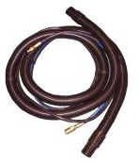

Smartkit-CH + Prespray-MX

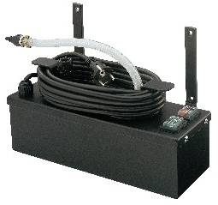
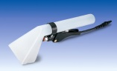

Hand tool NS10PN-M

Charis-DUAL

Charis-DUAL PROFESSIONAL SET includes:
- Machine body
- hoses H10-RAGNOL50-T
- the wand NS300-M
- the plastic hand-tool NS10PN-M, for cleaning upholstery and hard-to-reach spots
- the instant hot water unit HT1800
- the complete SMARTKIT-CH with PRESPRAY-MX, to perform automatic chemical dosing, pre-spraying and carpet rinsing.

Advantages with Charis-DUAL PROFESSIONAL SET:
  - The mechanical brushing action gives an excellent cleaning result, removing dirt completely from the base of carpet fibres. No residual dirt will re-emerge on carpet surface after few days!
  - Even a very dirty carpet can be completely clean in a single pass, reducing the time of cleaning operations.
  - Being able to clean in single pass, the amount of solution sprayed on carpet is not excessive and can be completely recovered by the machine’s high-waterlift vacuum system. As a result, carpet can be completely dry in one hour!

Complete Charis-DUAL Professional set, including:  machine body, hoses H10-RAGNOL50-T, carpet tool NS300-M, hand tool NS10PN-M,  instant hot water unit HT1800  SMARTKIT-CH for automatic chemical dosing and rinsing, with pipe and gun PRESPRAY-MX for carpet pre-spraying | €

